**NAME:**

**11AEMAM Test 8 2021**

**Section 1: /**

**Section 2: /**

**Total: /**

**%**

**TIME ALLOCATION FOR THIS TEST: 50 minutes**

**Section 1 – No Calculators Allowed.**

**minutes reading time: 2 minutes**

**minutes working time: 25 minutes**

**Section 2 – Calculators allowed**

**minutes reading time: 3 minutes**

**minutes working time: 35 minutes**

**Material required/recommended for this test**

**To be provided by the supervisor**

Question/answer booklets for Sections One and Two.

SCSA 11AEMAM Formulae Sheet

**To be provided by the candidate**

***Section One:***

Standard items: pens, pencils, pencil sharpener, highlighter, eraser, ruler

*Special materials: drawing instruments, templates, no notes, formula sheet*

Section Two:

Standard items: pens, pencils, pencil sharpener, highlighter, eraser, ruler

*Special materials: drawing instruments, templates, notes on a maximum of one unfolded sheet of A4 paper, double sided, up to three approved calculators, CAS, graphics, or scientific.*

**Important note to candidates**

No other items may be taken into the test room. It is **your** responsibility to ensure that you do not have any unauthorised notes or other items of a non-personal nature in the test room. If you have any unauthorised material with you, hand it to the teacher **before** reading any further.

|  |  |  |  |  |
| --- | --- | --- | --- | --- |
| **Section** | **Reading Time** | **Working time** | **Marks** | **Score** |
| **Resource free** | **2 minutes** | **25** | **22** | **%** |
| **Resource rich** | **3 minutes** | **30** | **35** | **%** |
| **Total** | **5 minutes** | **55** | **57** | **%** |

**SECTION 1 CALCULATOR FREE: 22 MINUTES**

**QUESTION 1 [2,2,2 = 6 marks]**

Find the derivative of the following functions. Express with positive indices.



1. b) c)



**QUESTION 2 [4 marks]**

Find the equation of the tangent line to the curve at the point (1,2).



**QUESTION 3** **[4 marks]**

Using first principles, = , show that the derivative of y = 3x2 is 6x.



QUESTION 4 [4,1,3 = 8 marks]

Consider the cubic function  over the domain .

1. Use calculus techniques to find the location and nature of the stationary points.

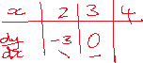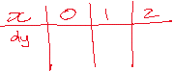

1. Find the – intercepts.



1. Graph the function over the given interval

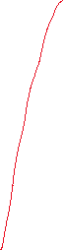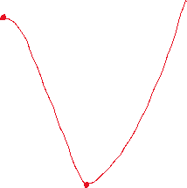

END OF SECTION 1

**Calculator Assumed Section** Name: …………………………………

Reading time: 3 minutes

Working time: 35 minutes Marks: 35

Question 5 [2, 4, 1 = 7 marks]

1. Determine the x-intercepts of the function



1. Hence, determine the rules for the lines that are tangent to the curve where it crosses the – axis.



1. Find where these tangent lines meet.



Question 6 [1,1,2,2,3 = 9 marks]

A bullet is fired upwards. After t seconds the height of the bullet is found from the rule where is measured in seconds and in metres.

1. Find the height of the bullet after 5 seconds.



The speed of the bullet is the instantaneous rate of change of the height of the bullet.

1. Find a rule for the speed of the bullet at any time .



1. Find the speed of the bullet after 5 seconds.



1. Find the maximum height of the bullet, to the nearest metre. Indicate your method.



1. Determine the bullet’s speed as it hits the ground, on the way down, to 2 decimal places.



Question 7 [3, 2 = 5 marks]

The total cost of producing x items of a particular type is given by and is such that .

(a) Find as a function of given that the cost of producing 10 items is $200.



(b) For what value of would the cost of production be a minimum and what would this cost be?



Question 8 [2, 2, 4 – 8 marks]

A pyramid with a rectangular base of length and width has perpendicular height . The length of the base is three times its width and the sum of the width, length and height is cm.

A pyramid with a rectangular base of length and width has perpendicular height . The length of the base is three times its width and the sum of the width, length and height is cm.

(a) Calculate the length, height and volume of the pyramid when cm.

|  |
| --- |
| **Solution** |
|  |
| **Specific behaviours** |
| ✓ correct length and height  ✓ correct volume |

(b) Show that the volume of the pyramid is given by .

|  |
| --- |
| **Solution** |
|  |
| **Specific behaviours** |
| ✓ expressions for length and height  ✓ substitutes width, length and height correctly |

(c) Use calculus to determine the maximum volume of the pyramid and state the dimensions required to achieve this volume.

|  |
| --- |
| **Solution** |
|  |
| **Specific behaviours** |
| ✓ correct derivative using given variables  ✓ solves derivative equal to zero  ✓ correct maximum volume  ✓ correct dimensions |

Question 9 [1,1,2,2 = 6 marks]

A sketch of f(x) =  has been provided below.

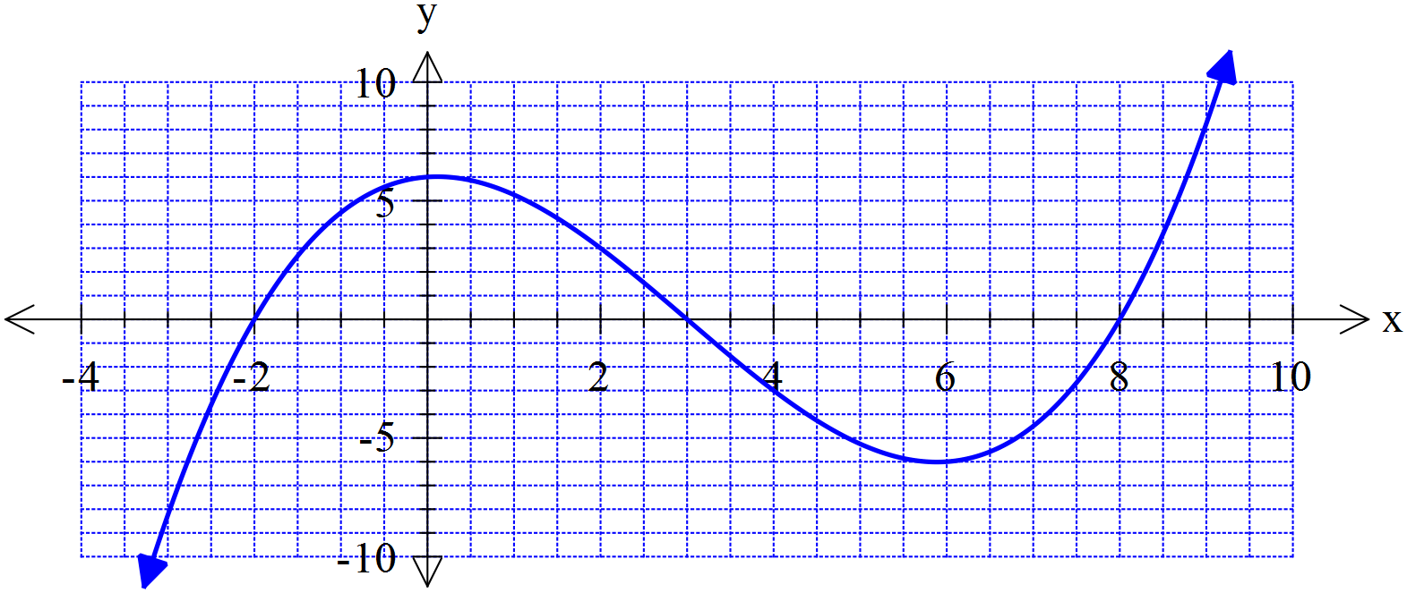



1. What is the average (mean) of the two positive roots of f(x)?



1. On the graph above sketch a tangent line to the curve for the value of x that you calculated in part (a).
2. Find the rule for this tangent line you drew above, that goes through the point where the x-value

is the average of the two positive roots. You may use your Class Pad.



A student has speculated that the tangent line to the curve at the average of two roots also intersects with the third root.

1. Use your answer from part c to show whether this statement is true or false for f(x).

Does this example support the student’s speculation or not? Discuss.



**End of Test**